UNIVERSITY OF NIS FACULTY OF MECHANICAL ENGINEERING

THE SEVENTH INTERNATIONAL CONFERENCE
TRANSPORT AND LOGISTICS

SAMPLE PAPER FOR A4 PAGE SIZE

First Author (Name and SURNAME)¹
Second Author (Name and SURNAME)²

¹⁾ First Author affiliation: Department, Organization

²⁾ Second Author affiliation: Department, Organization

Abstract

Abstract should be limited to no more than 15 lines of text. (Style Abstract: 10 pt, italic, font Times New Roman).

Key words: key word 1, key word 2... to (max) key word 6, min 3.
- INTRODUCTION (MAIN HEADING - UPPER CASE 10 PT, ALIGN LEFT, SPACING BEFORE 24 PT, SPACING AFTER 6 PT)
This document gives formatting instructions for authors preparing papers for publication in the Proceedings of an TIL2021 conference. The authors must follow the instructions given in the document for the papers to be published. You can use this document as both an instruction set and as a template into which you can type your own text. An electronic copy can be downloaded from the conference website.
Your paper must use a page size corresponding to A4 which is 210mm wide and 297mm long. The margins must be set as follows:
- Top = 20mm
- Bottom = 20mm
- Left = 20mm,
- Right = 20mm
Your paper must be in two column format with a space of 5mm between columns (equal colmn width).
Main text: only use characters and symbols available in the Times New Roman or Symbol font (as in the full text of paper), 10 pt; paragraph format: justified alignment, left and right indent 0 pt, space before and after 0 pt, first line indent 0 cm.
  - Subheading (10 pt, bold, left, indentation
left 0 pt, spacing before 12 pt, after 6 pt, keep with next, keep lines together)
Sample of main text. Sample of main text. Sample of main text. Sample of main text. Sample of main text. Sample of main text. Sample of main text. Sample of main text. Sample of main text. Sample of main text. Sample of main text. Sample of main text. Sample of main text.
Paragraph format for equations are: justify, 6 pt before and after, equation is at position of centered tab at 42.5mm, number of equation is at position of right tab at 85 mm. See Eq. (1).
$h_{ci}=\frac{q}{S\left(T_{wi}-T_{b}\right)}$ (1)
- PAGE LAYOUT
All illustrations (figures, photographs, line drawings, graphs) should be numbered in series and all legends should be included at the bottom of each illustration. All figures, photographs, line drawings and graphs, prepared in electronic form, should be converted in TIFF or JPG (max quality) files, in 300 dpi resolution, for superior reproduction.
All tables should be numbered with consecutive Arabic numbers. They should have descriptive captions at the top of each table and should be mentioned in the text.
The heading of the References section must not be numbered. When referring to a reference item, please simply use the reference number, as in [3].

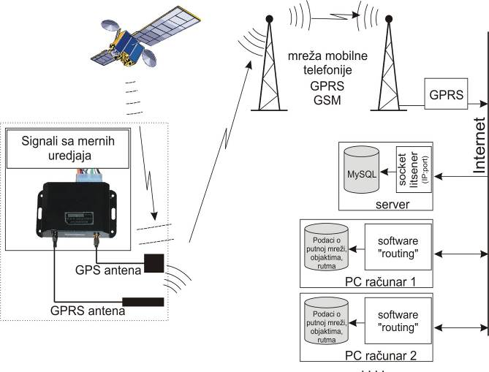
Fig. 1 Example
Table 1 Title of table
A | B
10 | 5
15 | -10
ACKNOWLEDGMENT
The paper is a part of the research done within the project 1234567890. The authors would like to thank to the.
REFERENCES
1. Blagojević, V., Milosavljević, Č., 2002, Application of digital sliding modes to synchronization of the work of two pneumatic cylinders, Facta Univesitatis Series Mechanical Engineering, 1(9), pp. 1275-1285.
2. Stojiljković, M., 2002, Logical synthesis of pneumatic control, Faculty of Mechanical Engineering, Niš, 376 p.
3. Muralidhara, H.S., 1998, Variable structure systems-A Survey, Proc. Sixth International Drying Symposium IDS 1988, Versailles, K1. 71.
4. Polat, O., 1989, Optimization of a Steam boiler, PhD Thesis, McGill University, Canada, 413 p.
5. Perkin, R.M., 1999, Feature models in Virtual Product Development, Report ECRC/M1677, Capenhurst, England.

Contact address:
Petar Petrović
University of Niš
Faculty of Mechanical engineering
18000 Niš
A. Medvedeva 14
E-mail: petar.petrovic@masfak.ni.ac.rs

